WHAT IS A TAX CREDIT?
ARIZONA TAX CREDIT
A tax credit is a dollar-for-dollar reduction in the actual tax owed to the State of Arizona. It reduces your tax liability by the amount you donate, up to $400 for married couples and
$200 for single or head of household. The tax credit can also be taken as a donation on your federal tax return.


WHAT ARE THE BENEFITS?
There are plenty! You, the taxpayer, get a Tax Credit for supporting our schools. The tax credit donation lets you choose how your tax dollars will be spent. Schools benefit because extra-curricular activities help children develop qualities such as leadership, personal growth and cooperation. They also provide safe, supervised activities for students. Everyone wins!

WHAT ARE EXTRA-CURRICULAR ACTITIVIES?
Extra-curricular activities are defined as school sponsored activities that require enrolled students to pay a fee in order to participate. Such activities include (but are not limited to): field trips, fine arts, music, and athletics, just to name a few.

WHO DO I CONTACT?
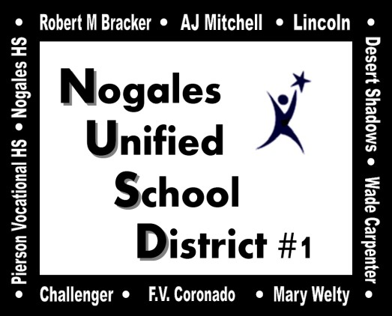
Nogales Unified School District 310 W Plum Street
Nogales, AZ 85621

You may call at 397-7947 or e-mail salcantar@nusd.k12.az.us for more information.

ADDITIONAL INFORMATION:
Because Nogales Unified School District must keep strict records of the funds received and report their use to the state, there will be no refunds should you discover that you do not have tax liability to cover the tax credit or for any other reasons.

*All tax credits are non-transferable and nonrefundable.
|


|

|

|

| ***YES! I would like to make a contribution.
| Date:_ Name:_
|
Address:_
|
City:_ State:_ Zip:_
|
E-Mail:_
| School: Desert Shadows Middle School
| Activity: Schoolwide- General Fund

| To Split Contribution:

|
School | Activity | Amount

|

|
| Mail this completed form and your check to:

Desert Shadows Middle School

340 Boulevard Del Rey David Nogales, AZ 85621
| Phone: 520.377.2646
ATTN : Mayra Garcia
|
A signed receipt will be mailed to you at the address
| above by January 31st.

| PLEASE NOTE:
This tax credit applies to contributions received
from individuals. It is NOT available to businesses.
| Must be Post Marked no later than December 31st
|
THANK YOU FOR YOUR CONTRIBUTION
Please make checks payable to: DSMS

|

|

|

